BACKPACK CLASS HOLLIDAY PARK PAVILION 2021

AM Schedule
9:30 – 10:00 Sign-in for Door Prize Tickets, Pre-registered attendees pick up Pavilion seating pass.
View Displays along sidewalk.

Presentation Schedule in Pavilion
10:00-10:15 Welcome & Trip Information
10:30-11:00 Risk Management & Preparation
11:15-11:45 Backpack Selection, Fitting, Packing
12:00-12:30 Leave No Trace
12:45– 1:00 Drawing for Door Prizes

PM Schedule
1:00-1:30 Sign-in for Door Prize Tickets, Pre-registered attendees pick up Pavilion seating pass.
View displays along sidewalk.

Presentation Schedule in Pavilion
1:30- 1:45 Welcome & Trip Information
2:00-2:30 Risk Management & Preparation
2:45-3:15 Backpack Selection, Fitting, Packing
3:30-4:00 Leave No Trace
4:15-4:30 Drawing for Door Prizes
Due to Covid-19 precautions the Pavilion tables are limited to 4 persons. You are welcome to stand or bring chairs in the overflow area on the east side of the Pavilion while practicing social distancing.

Beginner Backpack Trips
Dates Location
May 7 & 8 Hoosier National Forest, Story, IN
May 15 & 16 Hoosier National Forest, Story, IN
May 22 & 23 Charles Deam Wilderness
June 12 & 13 Shades State Park
June 12 & 13 Terrill Ridge, Charles Deam Wilderness
Register & view details @ ciwclub.org

Presenters
Steven Kinch, President CIWC
Robert Hart, Communications Chair
Rick Kischuk, Risk Management Chair
Leslie Green, Backpack Chair
Dave Hoffmeyer, Board Member

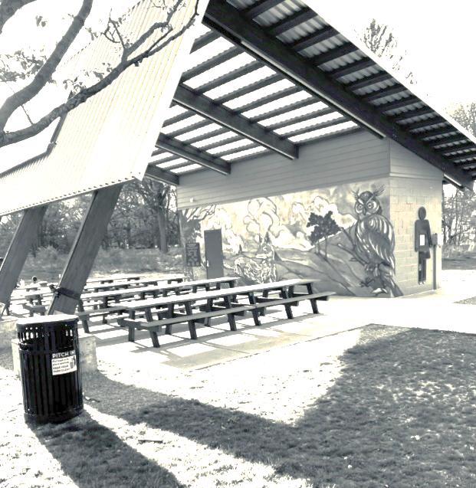
“Classrooms” are under the pop-up canopies. Please ask questions and check out the displays in each of the areas. In a normal year you would be able to try on packs and check out the gear. We regret that our displays are strictly “hands-off” this year due to Covid-19.
The Pavilion has limited seating of 32 people and those spots are reserved for our pre-registered attendees. The perimeter will be available for standing or sitting if you brought a chair. Please allow for social distancing.

As you enter the sidewalk closest to the playground there will be a registration table where you receive a ticket for the door prize drawings held at the end of the Leave No Trace presentation. We appreciate our retailers who have supported the Backpacking Class. Included in this hand-out are the dates and locations of our Beginners Backpacking Trips. Attendees who sign-in receive the first chance to reserve their place on these small group trips. You are not required to join CIWC for these short outings, but you are encouraged to become members. Monthly meetings are held in normal years and topics related to enjoying the outdoors are presented.
Our “Outdoor Classroom” is on both sides of the sidewalk leading toward the pavilion under the pop-up canopies. On the left is our “Tent City” with various types and sizes of Backpacking Tents. How to hang a food bag, use knots and how to start a campfire are in this area.
The areas are taped off to ensure social distancing and we appreciate your understanding in our efforts to meet health guidelines during this time.

As you leave the registration table, take time to ask questions and check out each display.

Topics in each area:
- “Leave No Trace”
- “Water Filtration and locations to backpack”
- “The 10 Essentials”
- “Wilderness First Aid”
- “Backpacks”
- “What’s for Dinner?” and “Cooking Stoves.”
- “Tent City”
- “Campfire Techniques”
Contact Us

Central Indiana Wilderness Club
PO Box 50083
Indianapolis, IN 46250

Visit us on the web: ciwclub.org
Ready to try backpacking but don’t have all the gear? Sign up for a Beginner Trip and we can help by loaning a backpack and tent. We have a limited number and will loan them out on a first-come, first-serve basis. Your dinner and breakfast are prepared using the Club stoves and water filters. You provide your own sleeping gear, eating utensils, lunch, snacks and water bottles.
In the event of inclement weather, the trip will be rescheduled.

